**LKS Newsletter**

Volume 4 - Sept 2024

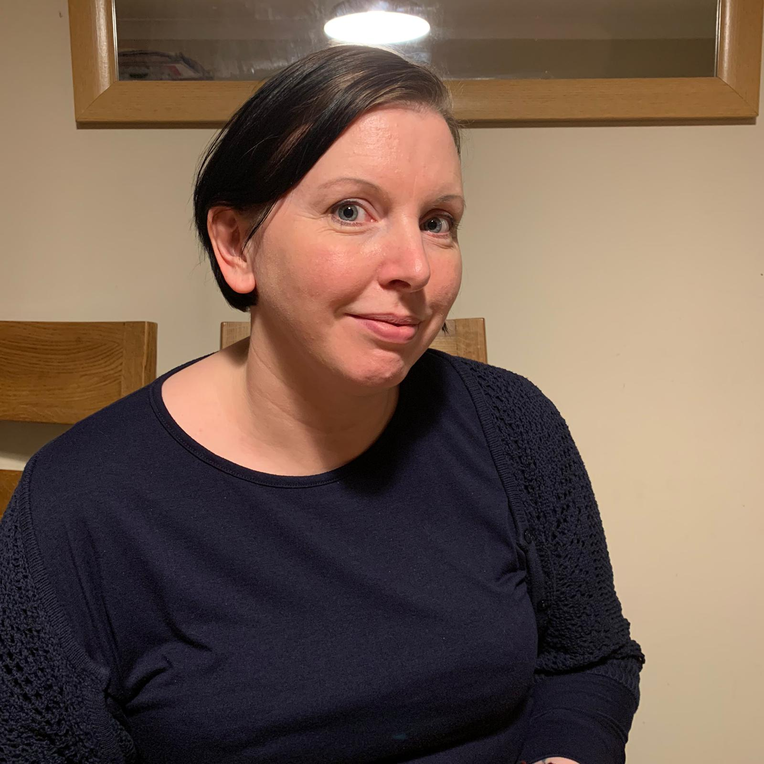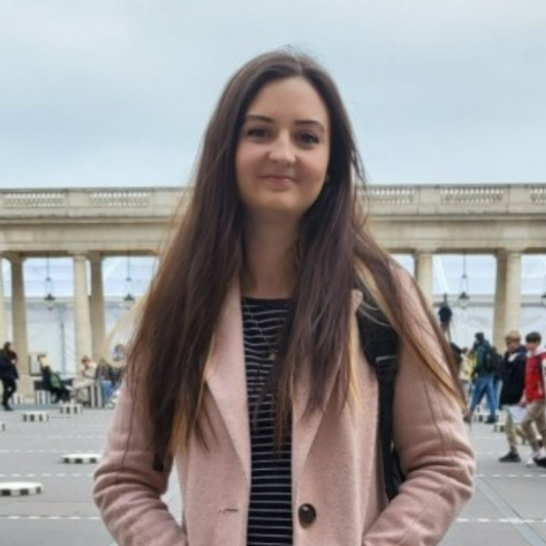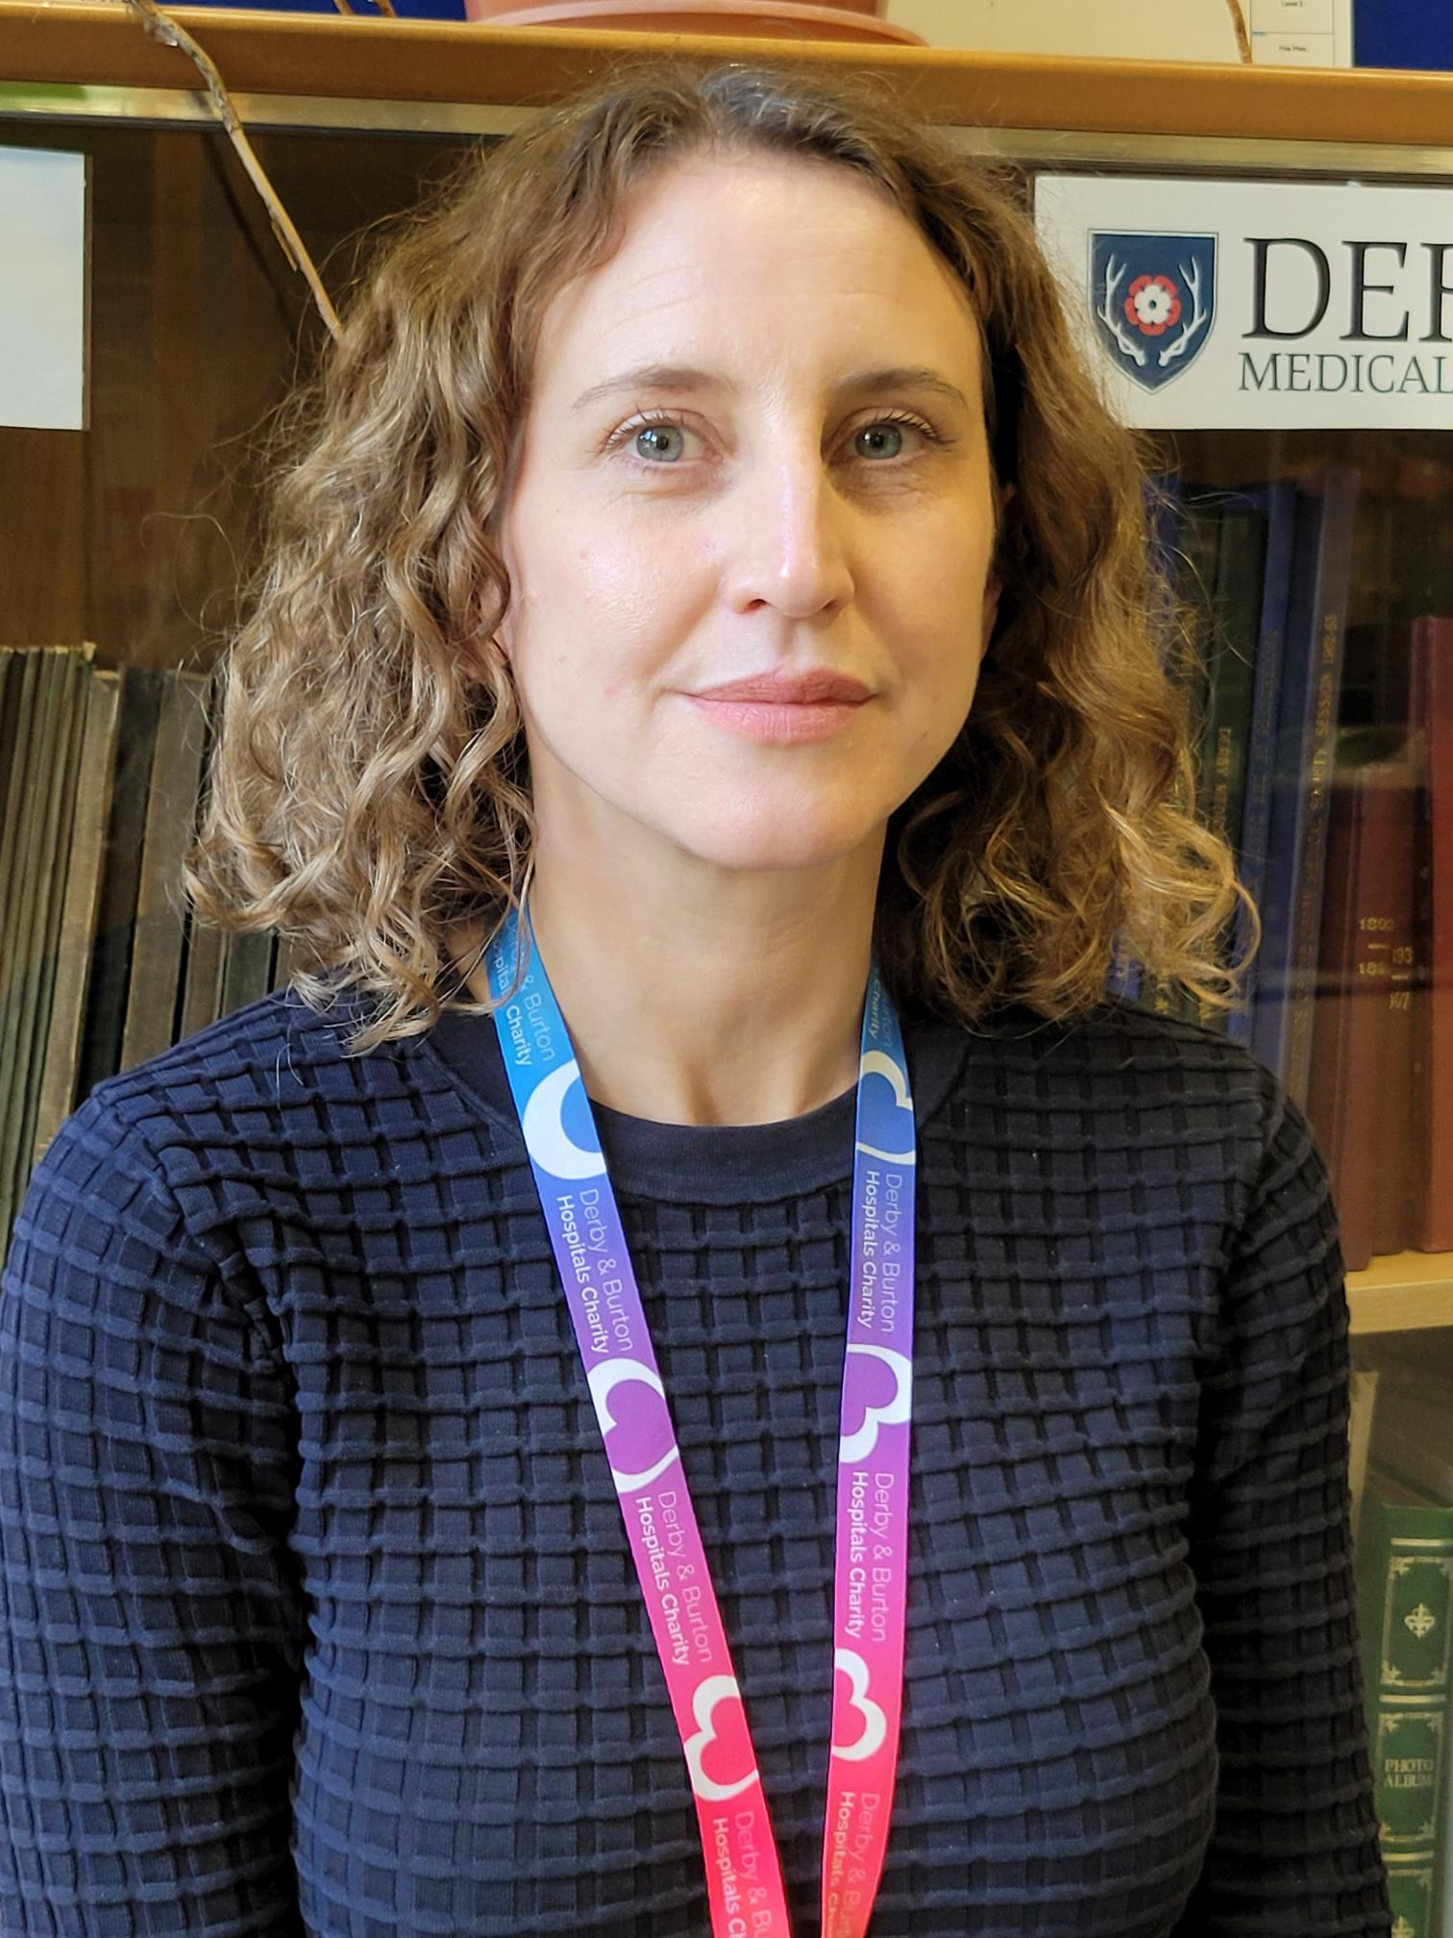

**LIBRARY TEAM WELCOMES NEW CLINICAL LIBRARIAN (CL) - HANNAH TUCKER**

Hannah joined us in early September and joins the existing CLs, Lisa and Lindsay, in providing the literature searches and training to find the evidence which underpins the work of the Trust. Welcome Hannah!

For more information about the Library's CL Service, contact [uhdb.library@nhs.net](mailto:uhdb.library@nhs.net).

**TWO LIBRARY TEAM MEMBERS PASS THEIR APPRENTICESHIP**

Amy Dolby and Jo Illsley have successfully passed their apprenticeships with distinctions.

Congratulations to them both!

**MEDICAL MUSEUM PROJECT SUCCESS**

The project, led by Beth Rawson (Deputy Library & Knowledge Service Manager and Museum Curator) in conjunction with Air Arts, has proved a great success (see Evaluation Report).: <https://tinyurl.com/52hm5cxa>.

1,000 objects have been lifted out of unsuitable temporary storage, fully researched, photographed and catalogued and made accessible on the UHDB Medical Museum website.

The project has raised awareness and increased knowledge of the collections and the medical history and personal stories they represent.  The newly researched collections have been used as a basis for a wide range of project activities including object handling workshops; Pop-up Museums; inspiration for artwork, exhibitions and mixed-media creative workshops; inspiration for developing clinical observation skills; development of Adult Patient Booklet and Child Patient Medical Museum Adventure Activity Sheet, exhibitions and interpretation across hospital sites, enhancing hospital visits and supporting medical training.

**PASS YOUR EXAMS!**

Register your interest for our free online question banks via BMJ OnExamination by contacting [uhdb.library@nhs.net](mailto:uhdb.library@nhs.net).

**LIBRARY SUPPORT FOR TRUST CLINICAL GUIDELINES, POLICIES AND PROCEDURAL DOCUMENTATION**

Members of the Library Team (Led up by Jo Illsley - Senior Library Assistant - Trust Documentation) have been working on the 'Koha Development Project'. Koha (Library Management Software) is currently used to store Trust guidelines and policies and will soon house SOPs (Standard Operating Procedures) which are being transferred from Net-i. The Library Team is dedicated to optimising the Koha system for our users and are actively seeking ways to streamline processes and improve the user experience.

So, if you'd like to be part of a user group to work on this project and provide input, please contact [amy.dolby@nhs.net](mailto:amy.dolby@nhs.net).

For general guidelines and other documentation queries and support, please contact the Library Team at [uhdb.policiesguidelines@nhs.net](mailto:uhdb.policiesguidelines@nhs.net). We are always willing to help and are committed to minimising risks and keeping our patients and colleagues safe.

**INTRODUCING THE SUSTAINABILITY COLLECTION!**

Committed to promoting sustainability and supporting the Trust's environmental goals, we're excited to unveil our new collection. There are almost 50 new books and an informative page on the library website to help educate and inform on topics such as climate change, green spaces and links to healthcare and wellbeing. You can also access nationally purchased content through the Kortext e-book platform, with helpful guides on how to access these and our collection on our webpage.

To launch the collection we held a prize draw, with lucky winners receiving sustainability related prizes! We would still appreciate your feedback on the collection, so please share your thoughts and suggestions for new titles.

Additionally, we're thrilled to announce that we've stopped using plastic book covers to reduce microplastic pollution. Thanks to an NHS England Green Grant, we'll expand our collection and bring more greenery to our libraries. Watch this (green) space!